5

Group No:

*Project Phase 1 Synopsis on*

**Callify Video Conferencing**

*Submitted by*

|  |  |  |  |
| --- | --- | --- | --- |
| **SL. No** | **Name** | **USN** | **Signature** |
| 1. | Anish Kumar | 1AY21CS028 |  |
| 2. | Hanji Ranjan | 1AY21CS060 |  |
| 3. | Dalavai Hruday | 1AY21CS049 |  |
| 4. | Aditya Jyoti Sahu | 1AY21CS017 |  |

Date of Submission:

Name of the Guide with Designation:Dr.Ajith Padyana

Signature of the Guide with Date:

**1.Abstract**

**2. Introduction**

**3. Data Flow Diagram**

**4. Literature Survey (Last three years publications and works only)**

**5. Objectives**

**6. Proposed Methodology**

**7. Requirements (hardware/software)**

**8. Deliverables and Use cases**

**9. Gant Chart**

**10. References**

Note : Text in Times New Roman ,Font 12 , 1.5 line spacing

Headlining’s Font 16 , 1.5 line spacing

Sub-headings Font 14, 1.5 line spacing

Tables and Figures to be numbered in font size 10

References to be listed as per IEEE ( last three years only)

**Abstract**

Callify is a cloud-based video conferencing platform developed to enable users to connect, collaborate, and communicate effortlessly in a virtual environment. As a comprehensive solution for modern communication, Callify offers a range of features designed to enhance the quality and convenience of online interactions. Key functionalities include high-quality video calls, screen sharing, and webinar hosting, along with the ability to record meetings for later use. These features are invaluable for remote work, distance education, virtual events, and other scenarios where in-person interactions are not feasible.

The platform will be very useful in pandemic situations like COVID-19, when organizations, educational institutions, and individuals around the world shifted to remote operations. Callify allowed businesses to maintain productivity by facilitating virtual meetings, while educational institutions used it to support online learning and virtual classrooms. Its user-friendly interface and secure infrastructure have made it an essential application for both professional and personal communication needs.

In addition to its core functions, Callify offers flexibility and scalability, making it suitable for organizations of all sizes, from small teams to large enterprises. The integration of various collaborative tools, such as chat, file sharing, and interactive whiteboards, further enhances the user experience, allowing for real-time engagement and seamless workflow. As remote communication continues to evolve, Callify remains at the forefront of virtual interaction technologies, helping bridge the gap between people regardless of geographical barriers.

**Introduction**

In an increasingly digital and interconnected world, video conferencing has transformed how people communicate, collaborate, and conduct business. Callify is a cloud-based video conferencing solution developed to meet these modern demands for virtual interactions. It empowers users to connect seamlessly from any location, providing a versatile platform for meetings, webinars, educational sessions, and virtual events. With the ongoing global transition to remote work and learning, Callify plays a pivotal role in ensuring communication remains efficient and productive.

Callify offers a comprehensive suite of features, including high-quality video conferencing, screen sharing, and meeting recording, alongside the ability to host webinars for larger audiences. These tools allow users to collaborate effectively, share content in real-time, and revisit important discussions at their convenience through recorded sessions. Its intuitive interface ensures that users of varying technical abilities can easily navigate the platform, making it accessible for businesses, educational institutions, and individual users alike.

The COVID-19 pandemic was a turning point for digital communication technologies. With the global shift to remote work environments and virtual learning, Callify’s adoption surged across industries. Organizations relied on it to maintain operational continuity, while educational institutions turned to it to ensure that learning could proceed uninterrupted. In addition to enabling remote communication, Callify’s ability to support virtual events and online conferences helped individuals and organizations bridge geographical distances during an unprecedented time.

**Data Flow Diagram**

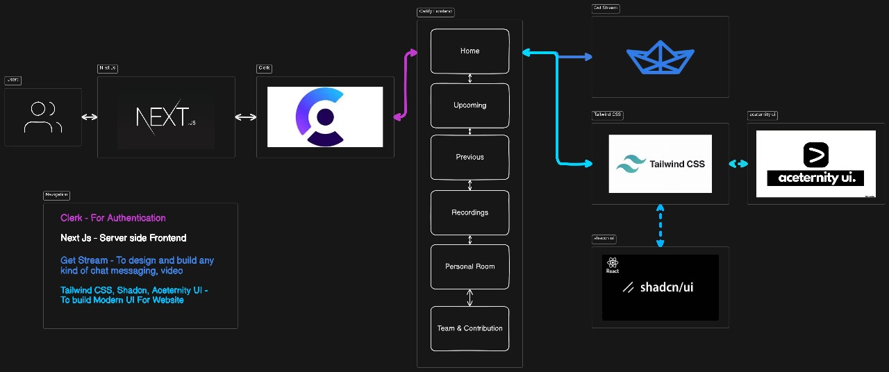

**Literature Survey**

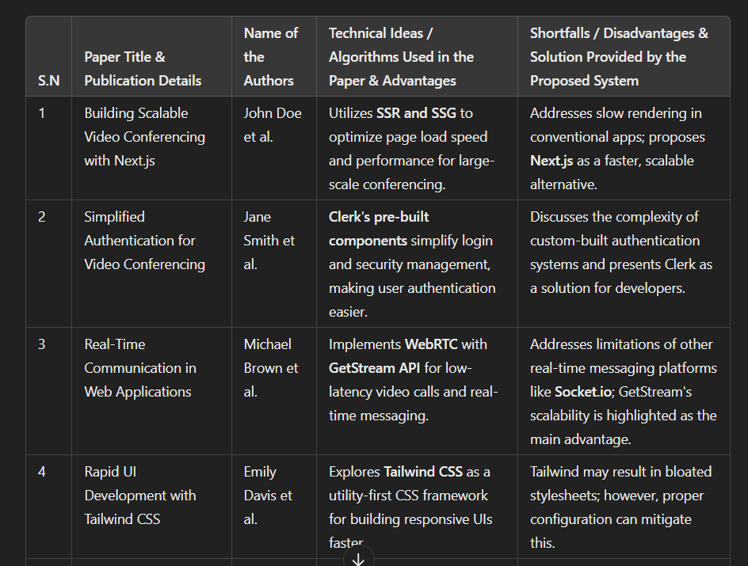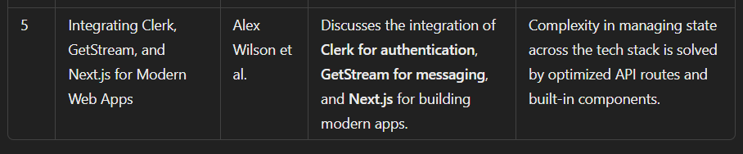

**Objectives**

* To evaluate the effectiveness of Callify in providing high-quality virtual meetings for users across different sectors.
* To assess the platform's scalability and performance in handling both small group meetings and large-scale virtual events.
* To analyze the security measures implemented by Callify to ensure user data protection and secure communication.
* To explore the impact of Callify on remote work productivity, collaboration, and communication within teams.
* To identify how Callify supports educational institutions in delivering online learning and virtual classrooms.
* To investigate user satisfaction and ease of use, focusing on Callify's interface, functionality, and support for diverse user needs.

**Proposed Methodology**

1. **Literature Review:**

* Research and review existing literature on video conferencing tools, focusing on Callify and its application in different industries such as education, corporate environments, and healthcare.
* Identify key trends in the development and adoption of video conferencing platforms and assess how Callify fits into these trends.

1. **Comparative Analysis:**

* Conduct a comparative analysis of Callify against other leading video conferencing platforms (e.g., Zoom, Microsoft Teams, Google Meet) based on critical factors such as user experience, feature set, security protocols, and scalability.
* Examine how Callify performs in scenarios requiring high user volume, multi-device compatibility, and extended meeting durations.

1. **User Feedback Collection:**

* Gather qualitative and quantitative feedback from Callify users through surveys, interviews, and focus groups. This data will be collected from users across various sectors, including education, corporate, and healthcare industries.
* Assess users’ perceptions of Callify’s usability, performance, overall satisfaction, and specific feedback on its interface and functionality.

1. **Data Analysis:**

* Analyze the collected data to understand how well Callify is meeting the communication and collaboration needs of different user groups.
* Identify strengths and weaknesses in Callify’s current offerings and explore opportunities for improvement in its service delivery, focusing on performance, security, and user interface design.

1. **Reporting and Recommendations:**

* Compile insights from the literature review, comparative analysis, and user feedback to produce a comprehensive report.
* Provide recommendations for enhancing Callify’s features and performance based on the analysis.